caAERS: Strong Password Policy

Technical Specification

1.0 | 10/18/2007 | Vinay Kumar
1.1 | 10/25/2007 | Karthik Iyer

Contacts and Support
Vinay Kumar  Vinay.kumar@semantocbits.com | NA
Karthik Iyer  Karthik.iyer@semanticbits.com | NA

LISTSERV facilities pertinent to software teams
LISTSERV | URL | Name
Caaersappdev-technical | caaersappdev-technical@gforge.nci.nih.gov | caAERS technical forum

Table of Contents
1. Password Policy Definition 1
2. Design approach 1
2.1 Three Scenarios 1
2.2 Validator Responsibilities 2
2.2.1 UserAccountCreationEventValidator [Administrator Intervention] 2
2.2.2 LoginEventValidator [system] 3
2.2.3 PasswordChangeEventValidator [system] 3
2.3 User Login 3
2.4 Changing Password 4
2.4.1 Password change at first login 4
2.4.2 User forgets password 5
2.4.3 Password expires 6
2.4.4 Password Policy Implementation 8
2.4.5 Password Persistence 10
2.4.6 Using an external authentication provider 10
2.5 Password policy XML schema 13

Password Policy Definition
Password policies are defined with the combination of various requirements. The proposed requirements should be enough to define the strong password policy for caAERS.
- Enforce password history determines the number of unique new passwords a user must use before an old password can be reused.[default: 3 passwords]
- Maximum password age determines how many days a password can be used before the user is required to change it. [default: 60 days]
- Minimum password age determines how many days a new password must be kept before the user can change it. This setting is designed to work with the Enforce password history setting so that users cannot quickly reset their passwords the required number of times, and then change back to their old passwords. [default: 2 days]
- Minimum password length determines the minimum number of characters a password can have. [default: 6 characters]
- Passwords must meet complexity requirements. User passwords meet the following requirements:
  - The password must be at least six characters long.
  - The password contains characters from at least three of the following five categories:
  - English uppercase characters (A - Z)
  - English lowercase characters (a - z)
  - Base 10 digits (0 - 9)
  - Non-alphanumeric (for example: !, $, #, or %)
  - The password does not contain three or more characters from the user's account name.
- Password should be stored with one way encryption
- Account lockout threshold - allowed login attempts before the user account is locked out. [default: 3 attempts]
- Account lockout duration - The password reset should not be allowed immediately and should be allowed after a while. [default: 30 minutes]

Design approach

Three Scenarios
Three activities have been identified as part of the design approach.
- User account creation.
- Logging into caAERS by the user.
- Password reset/change by the user.
These activities will be validated by their respective validators.
Activity validators
User account creation
User login
Password reset
UserAccountCreationEventValidator
LoginEventValidator
PasswordChangeEventValidator

Figure 1: Validators that handle various activities as part of caAERS password policy implementation

Validator Responsibilities

UserAccountCreationEventValidator [Administrator Intervention]
We envision this role will be performed by the administrator rather than the caAERS system. The typical scenario that will be handled by this role would begin with a user requesting an account in order to access caAERS. This may be done by submission of a web form that contains the requisite information for user account creation. The validator [who would typically be the caAERS system administrator] would then perform the necessary checks [like background checks] to ensure that the user indeed has authorization to use the system. Then the validator creates the user account and populates it with the necessary data [like first and last name of the user]. Finally the validator generates a time-bound token for the account and informs [through email] the user of the credentials to be used. Specifically, a URL will be sent through email [the email registered to the user account]. The user will click on the URL link and will be taken to the “set password” screen.

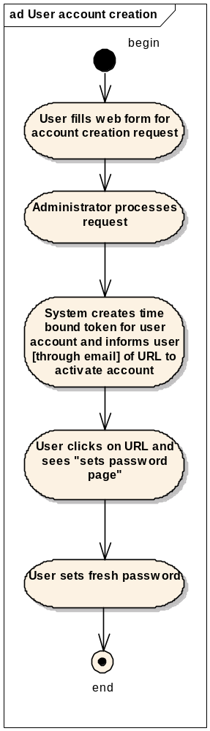
LoginEventValidator [system]
The LoginEventValidator enables the “User Login” activity. The user account policies are typically managed by this validator. The User Login section describes the validator’s role in greater detail. Typically this role can be realized in software which is more secure and consistent. This role is not administrator controlled.

PasswordChangeEventValidator [system]
This validator is used to enforce the caaers password policy definition. It enacts the “password change” activity which is described later in this document. Like the LoginEventValidator, the PasswordChangeEventValidator can also be realized in software. This role is not administrator controlled.

User Login
This is the entry point for the user to avail of the various features in the caAERS system. Once a user account has been created and users have set their passwords, they are ready to use caAERS. By default, user accounts will be in the unlocked status. At the login screen they will be prompted to enter their userid and password. If the correct password is entered, a check is made to ensure that the password is unexpired [maximum password age constraint], and the user is logged in successfully. Users are allowed a maximum of three attempts to login. In case they still fail, the account will be locked. This is to thwart hackers who may use login scripts to make unauthorized entry. After the account lockout duration has passed, the user may attempt to login again. Refer the figure below for the flow of the “User login” activity
Figure 2: Activity chart showing user account creation
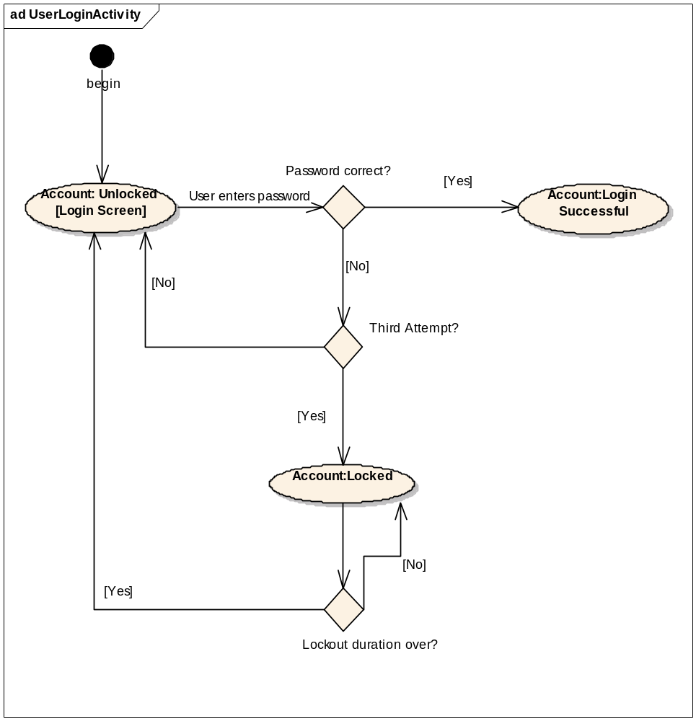
Figure 3: Activity chart for user login activity

Changing Password
There are various scenarios which would require users to change their password. We list the possible scenarios below.

Password change at first login
This scenario occurs when the user account has been recently created by the administrator and the user is logging in to the system for the first time. In such a case the system will enforce the policy of the user setting up a password for his account before he can start accessing system facilities. The activity diagram below shows the various steps that will be performed in this scenario.
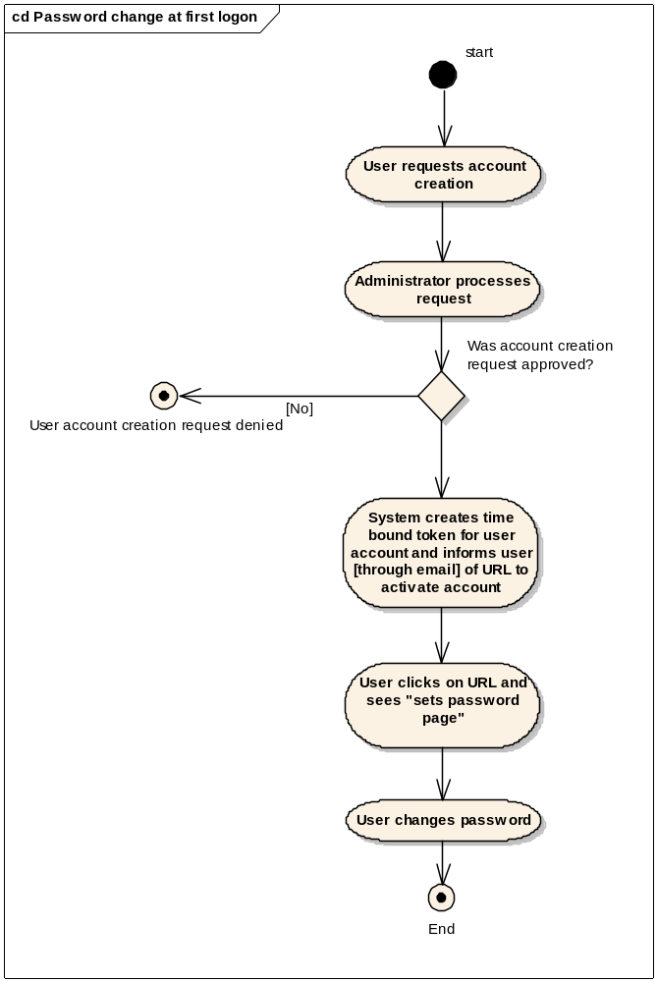
Figure 4: Activity chart showing the user initiated password change required at first login.

User forgets password
Another scenario where the user would need to change is password is when he forgets the existing password set in the system. In such a case, he would be required to inform the administrator of the problem. The administrator will generates a time-bound token for the account and informs [through email] the user of the credentials to be used. Using the credentials the system will allow the user to login. Similar to the “password change at first login” scenario, the user will be forced to change the password on his account. The adjoining figure shows the flow of the “user forgets password” activity. Note that the scenario assumes that the user is aware of the userid associated with the account. Another point to be noted is that this activity clashes with the minimum password age constraint, i.e. it is quite possible that a user may forget the password within the minimum password age duration. In such a scenario the administrator has the authority to override the minimum password age restriction. Administrator intervention also helps in avoiding abuse of the “forgot password” facility provided by the system.

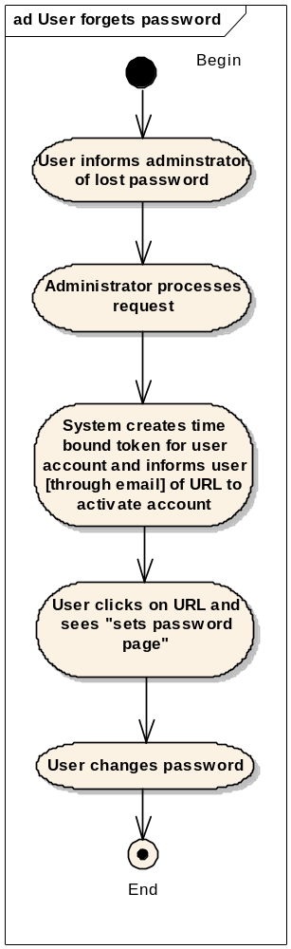
Password expires
Passwords have a maximum password age as stated in the password policy definition at the beginning of this document. They expire at the end of this time period. The system will issue warnings beginning 7 days prior to the date of password expiry. The warnings will appear on the screen whenever the user has managed to successfully login to the system. In addition, an email notification will be sent informing of password expiry. Users can then initiate the change password activity at this point of time. If users do not change their password in this 7 day period, the user account will be locked. They will then be required to contact the administrator who initiates the “user forgets password” workflow mentioned previously.
Figure 5: Activity chart showing user initiated password change due to lost password
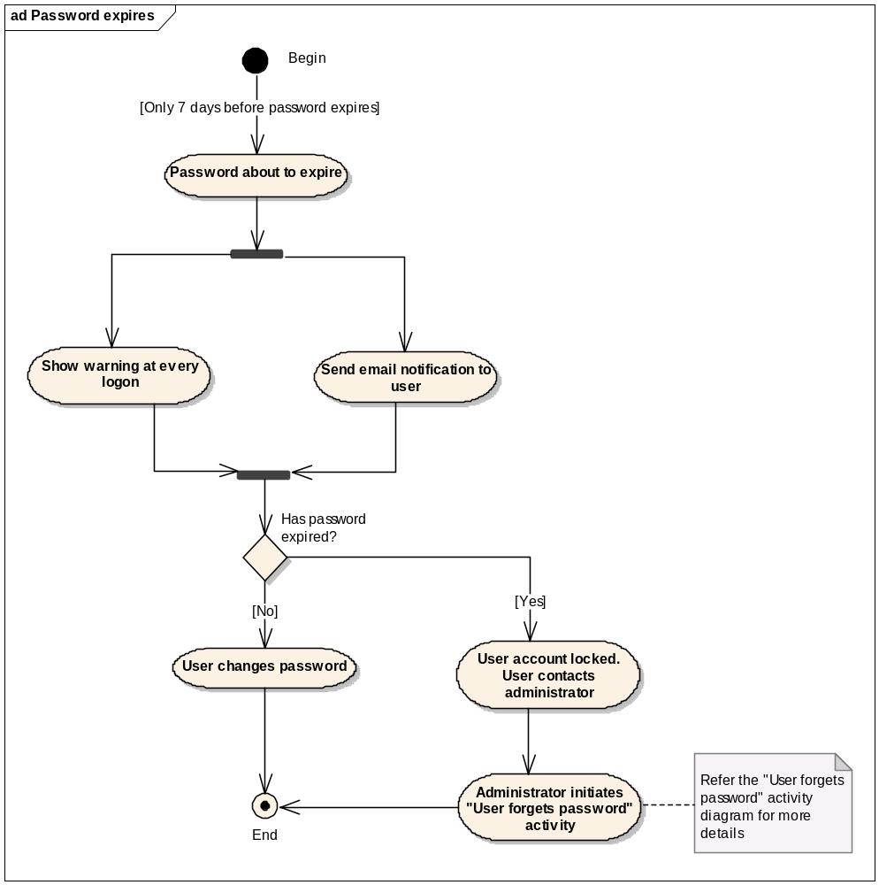
Figure 6: Activity chart showing user initiated password change due to password expiry.

Password Policy Implementation
The password policy implementation requires the following artifacts:
- The validation process during creation and reset of the password
- History of the password should be stored. It means it requires schema change
- Configuration of policy parameters - For configuring the parameters for password policy, an administrator provisioning screen has to be provided. It will require an introduction of one more jsp and schema change.
- Administrator will have the privileges of creating user.
- The Random Password Generator will generate the default password [confirming to the password policy above]
- User will be required to change password at first login.
The “Password change” activity is initiated by one of the above three scenarios. It implements the various requirements mentioned in the password policy definition section. Refer the following figure for a high level view of the activity.

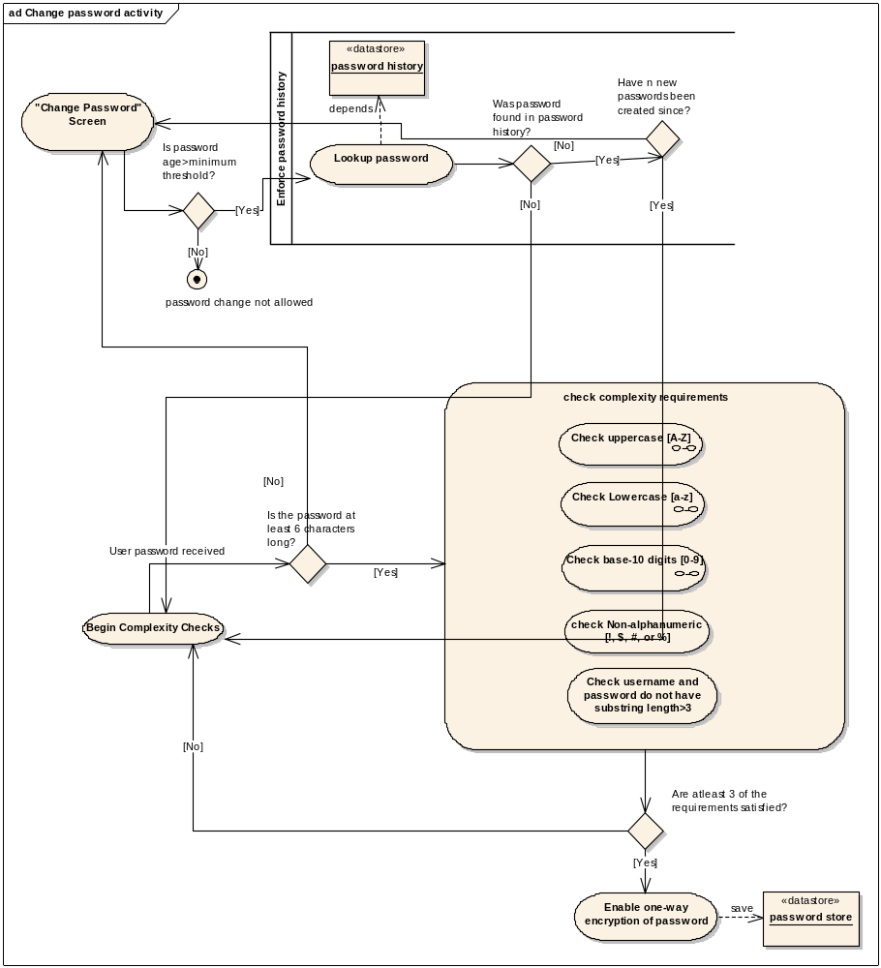
Figure 7: The password change activity showing how the password policy definitions are implemented

Password Persistence
Password string
Password store
One way encryption
Figure 8: Hashing and storage of passwords.

Passwords are stored in a password store after applying a one-way encryption algorithm on them. One way encryption is implemented using hash functions. Using hash functions one creates a “hash” of the password string and stores it in the password store. This improves security. For example, in case the password file is stolen, the hacker will not be able to retrieve user passwords from the encrypted file. This is because once the passwords are hashed the process is irreversible; they cannot be “unhashed.” Due to this reason, if the user loses his password the system will be unable to send him the existing password. The user has to then perform the “change password” activity after logging in to his account with a system generated password.

Using an external authentication provider
caAERS
Credential provider
LDAP
Existing user credentials
Figure 9: Configuring caAERS to use an external authentication provider.

caAERS will be designed to be highly configurable. The system administrator will be able to quickly switch between local and external credential provider. This need may arise in case the user account database is external to the caAERS system. For example some organizations may already have a LDAP data store that manages user accounts and their policies. Such organizations may prefer that caAERS respect user account policies as has been specified in the organization. In such cases the administrator will configure caAERS to switch off the default user account policy implementation. This also adds the convenience of not recreating user accounts specifically for caAERS. By default, caAERS will be configured to manage user accounts. This includes,

- Creating user accounts.
- Enforcing User account policy.
- Enforcing the password policy.
- Maintaining the password datastore
If the user account policies are managed external to caAERS, the “change password”, “forgot password” functionalities will not be available in caAERS. SAML will be used to communicate with the external password datastore.
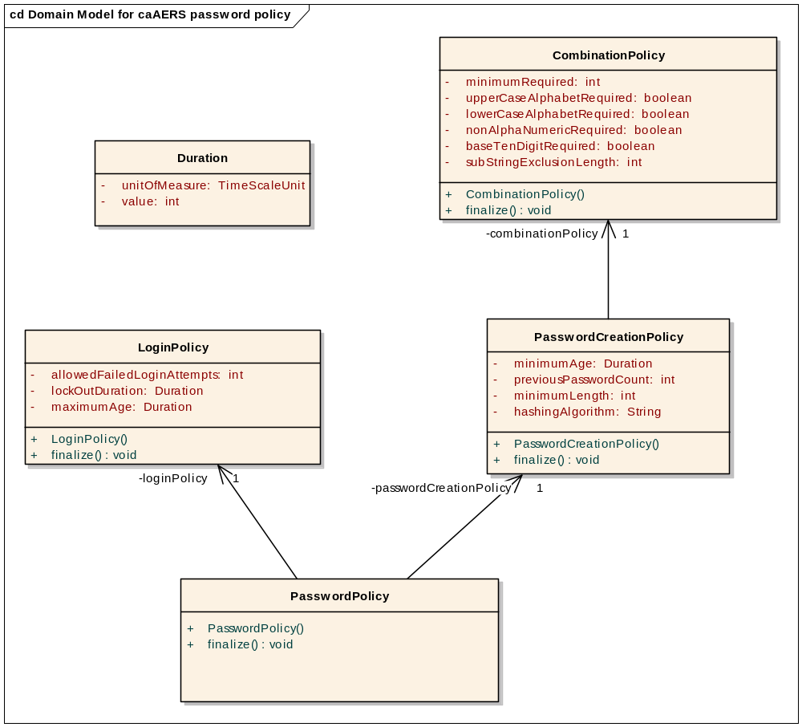
Figure 10: Domain model for the caAERS password policy.
